Laboratory Practical Report

of

**GRAPH THEORY**

**(ICT ED 478)**

Submitted To

**TRIBHUVAN UNIVERSITY**

In Partial Fulfillment of the Requirements of the course

**B.Ed. ICTE 6th Semester**

Submitted By

Sanam Tamang

Symbol No.: 76214020

T.U. Regd. No.: 9-2-214-54-2019

Under the guidance of

**MR. KALYAN DAHAL**

Lecturer

Sukuna Multiple Campus

**TREES AND FOREST**

**a. TREES**

A tree is an undirected graph that is connected and acyclic, meaning it does not contain any cycles or loops. It is a fundamental concept in graph theory and has several important properties.

Formally, a tree is defined as an undirected graph G = (V, E), where V represents a set of vertices or nodes, and E represents a set of edges connecting the vertices. The graph must satisfy the following conditions to be considered a tree:

1. Connectedness: Every pair of vertices in the graph must be connected by a unique path. In other words, there is a path between any two vertices.
2. Acyclicity: The graph must not contain any cycles or loops. A cycle is a closed path in which the first and last vertices are the same, and all the intermediate vertices are distinct.

Additionally, a tree satisfies the following properties:

1. Unique Path: There is a unique path between any pair of vertices in a tree.
2. No Loops: Trees do not contain loops or cycles, making them acyclic.
3. Minimum Number of Edges: A tree with n vertices will have exactly n-1 edges. Adding an edge to a tree will create a cycle, and removing an edge will disconnect the graph.

Trees have numerous applications in various areas, including computer science, data structures, network design, algorithms, and more. They serve as a fundamental data structure for organizing hierarchical data, implementing search algorithms, representing family trees, modeling network connections, and solving optimization problems.

**b. FOREST**

A forest is a collection of disjoint trees. It is an undirected graph that consists of multiple disconnected trees. Each tree within a forest is considered an individual component, and the entire forest is formed by combining these components.

Formally, a forest is defined as an undirected graph G = (V, E), where V represents a set of vertices or nodes, and E represents a set of edges connecting the vertices. Unlike a tree, a forest does not necessarily have to be connected.

A forest can be thought of as a collection of several separate "islands" of trees, where each island represents a tree. Each tree within the forest follows the same properties as a tree in graph theory:

1. Connectedness: Every pair of vertices within a tree is connected by a unique path.
2. Acyclicity: Each tree within the forest is acyclic, meaning it does not contain any cycles or loops.

Forests are useful in various applications, especially when dealing with disconnected or independent components. They can be used to represent disjoint structures or separate entities within a system. Examples of real-world applications of forests include computer networks with multiple disconnected sub networks, organizational structures with separate departments, and hierarchical data with multiple independent trees.

Top of Form

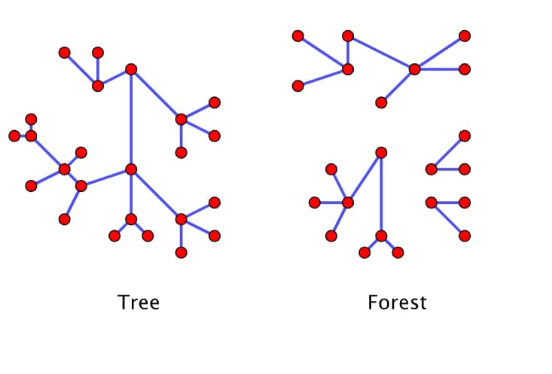

**THEOREM**

**If G is a tree with n vertices then it has n-1 edges.**

This property can be proven using induction or by considering the definition of a tree and the number of edges required to connect its vertices. Let's briefly explain the proof by induction:

Base case: For a tree with n = 1 vertex, there are no edges. The statement holds true as 1 - 1 = 0 edges.

Inductive step: Assume that the statement is true for a tree with k vertices, where k ≥ 1. That is, a tree with k vertices will have k - 1 edges.

Now, consider a tree with (k+1) vertices. We can pick any leaf vertex (a vertex of degree 1) from this tree and remove it along with its incident edge. The resulting tree will have k vertices.

By the induction hypothesis, the tree with k vertices will have (k - 1) edges. When we add back the removed vertex and its incident edge, the total number of edges becomes (k - 1) + 1 = k.

Therefore, a tree with (k+1) vertices will have k edges.

By the principle of mathematical induction, the statement holds for all positive integers n ≥ 1. Hence, if G is a tree with n vertices, it will have exactly n-1 edges.

Top of Form

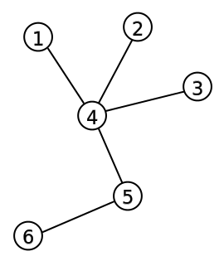Top of Form